CS7GV5 Assignment Report PART 1 **Hand hierarchy in OpenGL**

Under the Guideline of Professor Rachel Mc Donnell  
Implemented by Yuzhou Shao  
Trinity College Student id: 19322035  
Youtube Demo: <https://youtu.be/zyuUL3F0ZvY>

The main.cpp code is also attached on the zip file.

Summary:

This project has implemented a Robotic Hand using transformations and hierarchies in OpenGL.

As my Youtube Demo shows, translate parent-whole object translates, Rotate child-only child rotates, and Rotate parent-whole object rotates are implemented successfully.

An abstract object of a 3D box were imported to stand for the palm.

Another 15 identical 3D Springs were imported to stand for the segments of 4 general fingers plus a thumb.

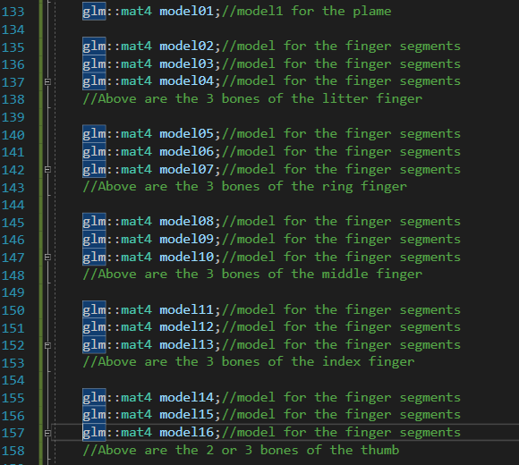

The underlying mechanism of Bone or Skeleton Class were implemented. Each bone has its own ID as above.

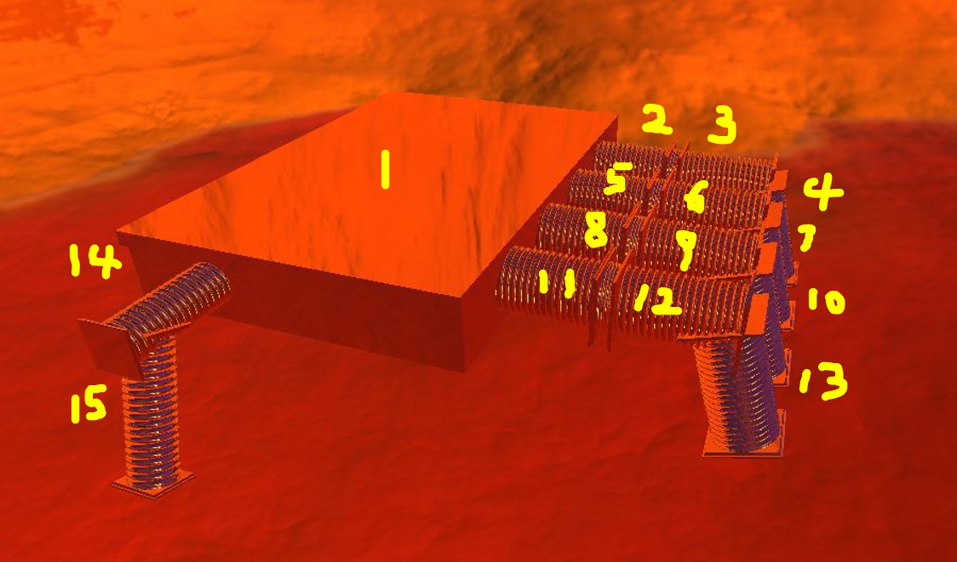

The lower bone of each fingers, which are model02, model05, model08, model 11, and model14 for little finger, ring finger, middle finger, index finger and thumb respectively, were the child node of the parent node of palm whose ID is model01.

The middle bone next to the lower bone is the child of the latter. And the upper bone is the child of the parent of the middle bone.

Let’s take the little finger as an example, modle02 which is the lower bone, is the child of model01 which stands for palm.

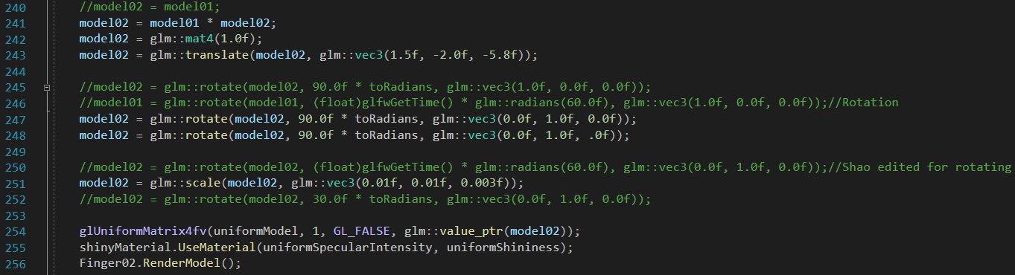

And model03 which is the middle bone, is the child of model02.

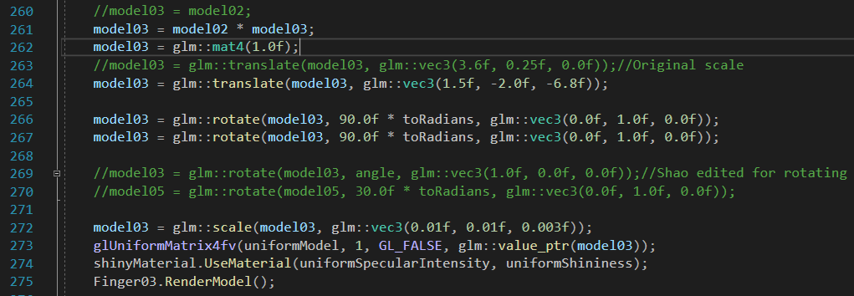

Furthermore, model04 which stands for the upper bone, is the child of model03.

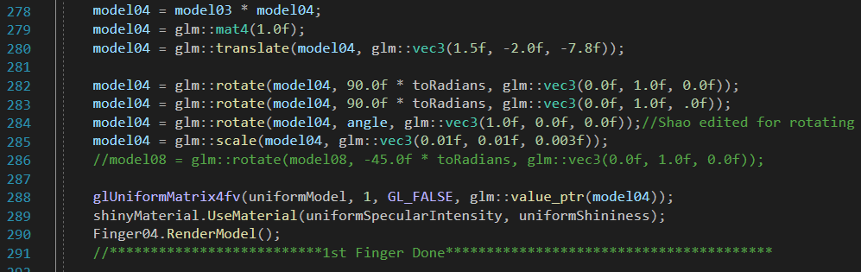

The hierarchy is implemented through multiplication of the GLM models, as above screenshot, see the lines of 278, 261 and 241 respectively.

Translate, Rotate, and Scale are all implemented in GLM for placing each bones in their suitable positions and angles.

With the help of glfwGetTime(), the dynamic rotation for bones are implemented.



With the help of if loop, the angles constraint of the rotation are implemented successfully. Moreover, the nested if loops, achieves the interactions during the rotations between parent and child hierarchy bones.

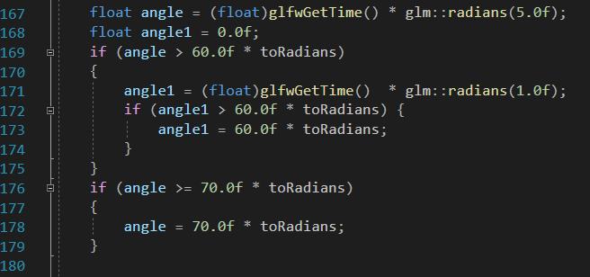



Lastly, the transmittance effect of the shader files makes the texture of the bone reflective with a impressive appearance.

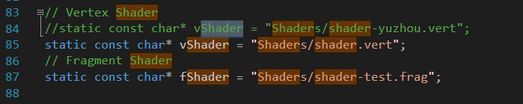

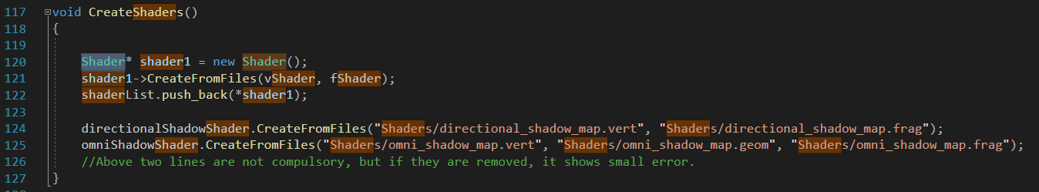

At the end, as it shows in my Youtube demo, pitch, roll, yaw and translate are all implemented for the entire Hand in hierarchy. It is implemented through if loops of GLFW under camera view function.

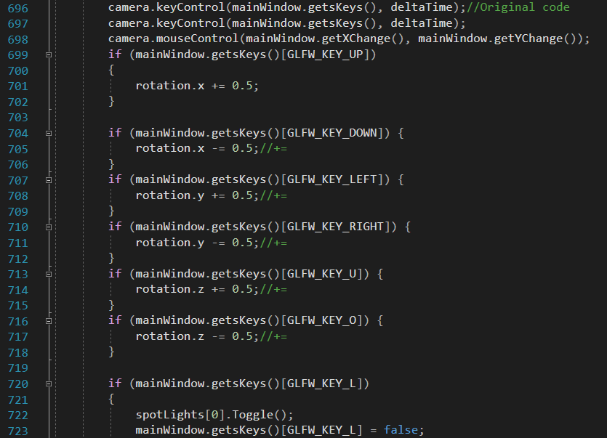

And each bones of the fingers can rotate individually with the help of shifting the code dynamic rotation it the intended bones.



Reference:

[The OpenGL Programming Guide (opengl-redbook.com)](http://www.opengl-redbook.com/)

<https://learnopengl.com/>